WD2 abundance indices

There is landings per unit effort information available from UK and Dutch vessels. Here we describe briefly the UK and in more detail the Dutch information and present a number of alternative ways to standardize the time-series to be used in the Turbot assessment.

# UK data

A description of the origin of the UK data is not available and the methods used to standardize the time-series is lacking as well. An area-based analyses has been performed and area-sums were provided as CPUE time-series which are shown below. In recent years, the Otter trawl hardly catch any Turbot and the selected time-series for trial assessment runs relies on beam trawl data only.

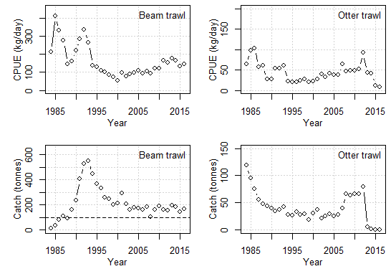

Figure 1. LPUEs and Catches for UK beam trawl and UK otter trawls

## Dutch data

LpUE information for Dutch vessels is obtained from logbook registrations which are reliably available since 1995 (introduction of a new database at the compliance company). Logbook records of all vessels catching either sole, plaice or turbot were selected, fishing with a mesh size >70 and smaller than 100mm and registered as fishing with a TBB gear. Since 2009, the fleet has transitioned to innovative gear types, replacing the beam with a wing design and replacing the tickler chains with pulse stimuli. These changes may result in different catchabilities which is why they are analysed separately to investigate the differences. Figure 2 shows the individual LpUEs for these fleets, clearly showing markedly different absolute LpUE values, while trends in especially pulse and traditional beamtrawl seem similar.

Not only their catchability is different, their predominant fishing location differs as well, as can be seen in Figure 3. The pulse fleet now inhabits the more traditional sole grounds in the southern North Sea while the remaining traditional beam trawlers fish in the northerly areas of the original distribution range, in areas where more Turbot is caught. It is therefore that we have to correct for gear and area when standardizing the LpUE for the Dutch vessels.

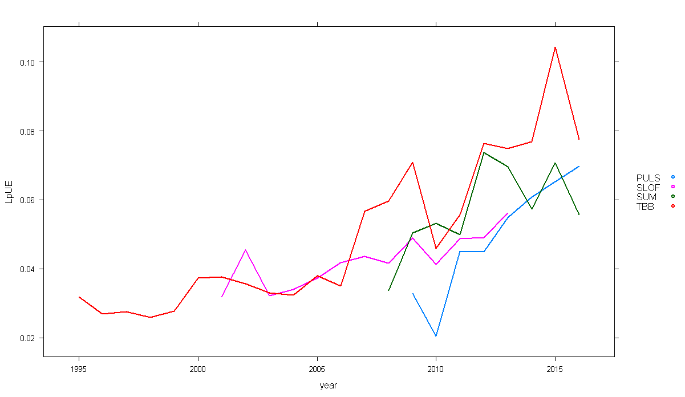

Figure 2. LpUE for the traditional beamtrawl (TBB, in red), the chainmat fishery (SLOF, in pink, discontinued), the wing-design (SUM, in green) and the pulse design (PULS, in blue).

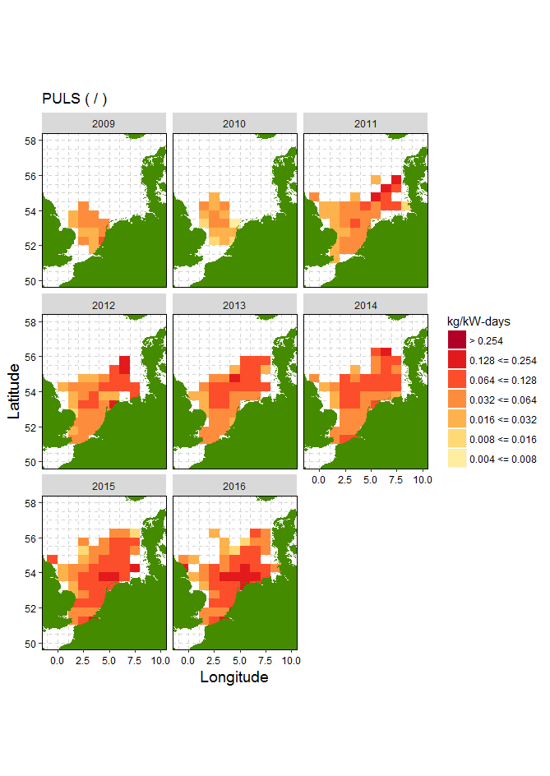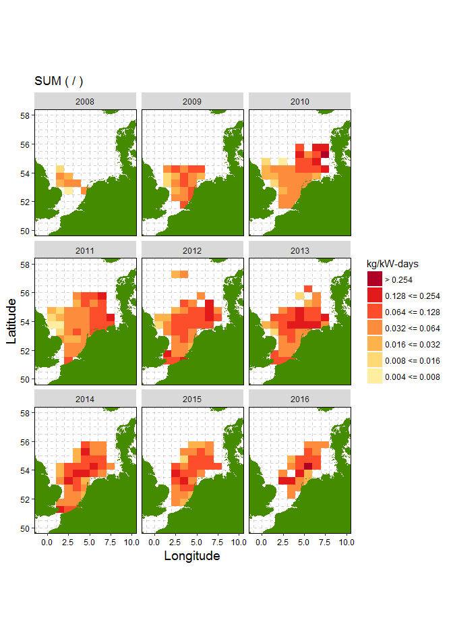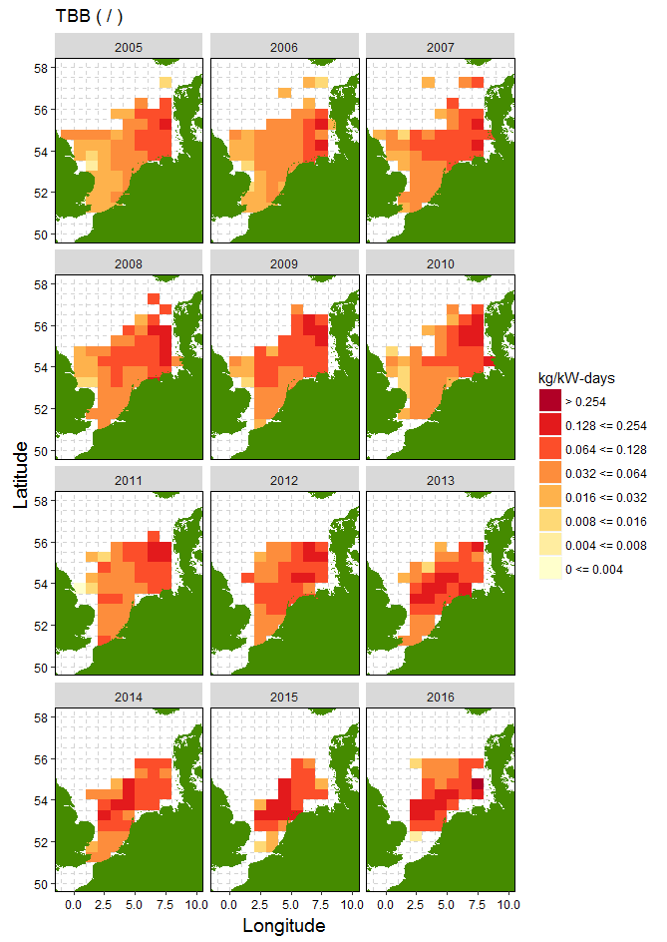

Figure 3. Spatial distribution of the puls, sumwing and traditional beamtrawl fleet over the years

## Statistical model

To standardize the survey and retrieve a time-series of year effects a statistical model was designed including interactions in space, time and gear. As raw LpUEs were calculated on a trip & rectangle basis, effort per rectangle is taken as a weighting factor in the analyses. Only rectangles in which fishing occurred in 11 or more years were taken on-board. This amounted to 99% of all Turbot catches since 1995. Several different model configurations were tested and analysed. In general, residuals did not show patterns and all configurations seem statistically appropriate. AIC and BIC criteria were calculated to help guide a pending decision on which series to use in the assessment.

The models fitted were:

|  |  |  |  |
| --- | --- | --- | --- |
| Model | Description | AIC | BIC |
| A | te(SI_LONG,SI_LATI,k=5)+as.factor(year) + LE_GEAR_INNOV | 2935 | 3180 |
| B | te(SI_LONG,SI_LATI, year,k=5)+ LE_GEAR_INNOV | 2656 | 3112 |
| C | te(SI_LONG,SI_LATI,k=5)+te(year,k=10) + LE_GEAR_INNOV | 3053 | 3230 |
| D | te(SI_LONG,SI_LATI, by=as.factor(year),k=5)+ as.factor(year) + LE_GEAR_INNOV | 1618 | 3540 |

Although model D shows a clear drop in AIC, the increased use of parameters is substantial as shown with the BIC criteria. Predicted year effects are shown in Figure 4, where predicted year effects of model A, C and D are very similar but only show a different intercept while model B is markedly smoother but shows the same absolute increase as the other series (increase from 1995 - between 0.057 and 0.063). Model O refers to the currently used LpUE in the WGNSSK assessment of Turbot.



Figure 4. Predicted LpUE for each of the models, using TBB and a fixed rectangle as prediction conditions.

Table 1. Table with predicted LpUE values.

|  |  |  |  |  |
| --- | --- | --- | --- | --- |
| Year | Model A | Model B | Model C | Model D |
| 1995 | 0.029005 | 0.038529 | 0.029363 | 0.042271 |
| 1996 | 0.027062 | 0.038195 | 0.026905 | 0.036913 |
| 1997 | 0.027335 | 0.037984 | 0.025623 | 0.037283 |
| 1998 | 0.025017 | 0.038016 | 0.026249 | 0.034519 |
| 1999 | 0.026537 | 0.038413 | 0.028531 | 0.034486 |
| 2000 | 0.034002 | 0.039312 | 0.031457 | 0.04409 |
| 2001 | 0.034816 | 0.040855 | 0.033822 | 0.045691 |
| 2002 | 0.032115 | 0.043007 | 0.034406 | 0.045351 |
| 2003 | 0.033646 | 0.045625 | 0.03286 | 0.046866 |
| 2004 | 0.032734 | 0.048528 | 0.031886 | 0.047674 |
| 2005 | 0.034629 | 0.051486 | 0.034407 | 0.047145 |
| 2006 | 0.036482 | 0.054218 | 0.040011 | 0.048433 |
| 2007 | 0.047572 | 0.056635 | 0.04497 | 0.064184 |
| 2008 | 0.048819 | 0.058904 | 0.046521 | 0.066611 |
| 2009 | 0.047743 | 0.061238 | 0.046382 | 0.065974 |
| 2010 | 0.042706 | 0.06389 | 0.046822 | 0.058335 |
| 2011 | 0.047261 | 0.067153 | 0.049329 | 0.059202 |
| 2012 | 0.060853 | 0.071256 | 0.055399 | 0.073476 |
| 2013 | 0.068966 | 0.07621 | 0.064454 | 0.075294 |
| 2014 | 0.067846 | 0.081994 | 0.073163 | 0.074674 |
| 2015 | 0.075625 | 0.088567 | 0.078832 | 0.087463 |
| 2016 | 0.086205 | 0.095856 | 0.082574 | 0.097216 |